Elettra, Present And Future
E. Karantzoulis†, A. Carniel, S. Krecic, Elettra – Sincrotrone Trieste, Trieste, Italy

Abstract
The operational status of the Italian 2.4/2.0 GeV third generation light source Elettra is presented together with the final version of the upcoming upgrade, the diffraction limited light source Elettra 2.0.

introduction
Located on the outskirts of Trieste, Elettra operates for users since 1994 being the first third generation light source for soft X-rays in Europe. During those 25 years, many improvements were made in order to keep the machine updated and therefore competitive with the other more recent and modern light sources already designed to operate in top-up. Following the successful set in operation of the full energy injector in 2008, after 14 years of energy ramping, Elettra established top-up operations [5] in spring 2010, although not originally designed for it. Operating in top-up proved to be and still is very beneficial for the machine [2]. Except the above-mentioned big upgrades, other minor ones took place aiming to the smooth and reliable operation of Elettra, and many possible scenarios were studied aiming in increasing the machine capabilities, as reported previously [3-6]. Those scenarios were not realized since it has been decided that the light source should undergo a massive upgrade that will render the machine competitive for the next 25 years, namely to replace Elettra with a new diffraction limited light source, Elettra 2.0.

elettra status
Elettra operates 24 hours/day, seven days a week delivering more than 5000 hours/year of synchrotron light from IR to soft x-rays to 28 beam lines of which bending magnets serve ten. Two beam-lines use light from a superconducting 49-pole, 64-mm period, 3.5 T wiggler.
Many types of insertion devices are installed such as planar, Figure-8, APPLE II, electromagnetic, superconducting while one beam line uses a canted set of APPLE II type undulators occupying all the eleven available long straights while dispersive short straights are also used for insertion devices. A short undulator in a short straight serves the TwinMic beam-line while there are plans for more beam lines.
The machine consists of a 100-MeV linac, a 2.5 GeV booster and a 2.0/2.4 GeV storage ring. At about 75% of user-dedicated time Elettra operates at 2 GeV while for the remaining 25% at 2.4 GeV, being the only facility to operate at two energies (both in top-up). The main operating modes are multi-bunch with a dark gap of 42 ns and hybrid (in 2018 at 42% of the total user beam time) i.e. multi-bunch with one (for time resolved experiments) or two single bunches (distant 40 ns in a dark gap of 120 ns for pump and probe experiments). The operating intensities are 310 mA at 2 GeV and 160 mA at 2.4 GeV with 5 mA single bunch(es) is (are) added when in hybrid mode.

†emanuel.karantzoulis@elettra.eu (2019)
In Fig.1, the total availability (green bars) is shown during the three phases of operation; in fact before 2008 the storage ring ramped in energy, whereas after 2008 operates with a full energy injector and since 2010 in top-up. The numbers clearly show a continuous improvement of the availability.
Another important number indicative of the reliability of a light source is the Mean Time between Failures (MTBF, Fig. 1, red bars). The mean maximum time between failures is currently at about 360 hours with peaks at 550 hours.

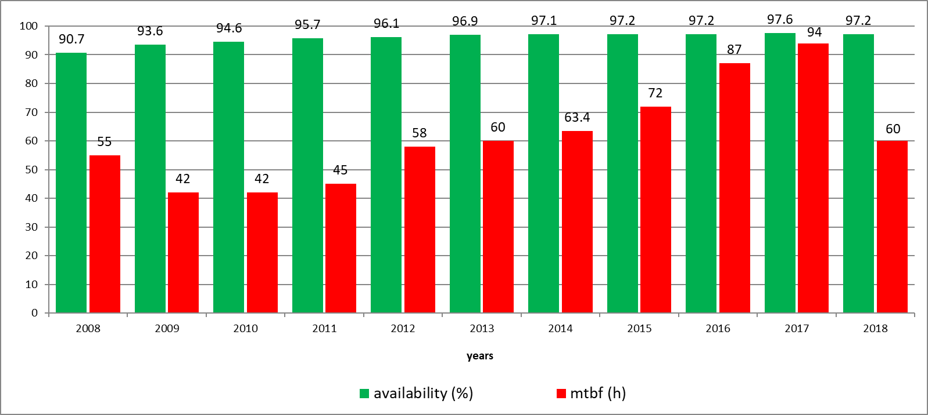
Figure 1: Combined graph of Electra availability (in %, green bars) and MTBF (in hours, red bars).
The downtime distribution amongst the subsystems of Elettra is shown in Fig. 2, a large portion of the downtime is due to external causes (electric power surges), RF and water-cooling that in 2018 after a massive maintenance the system became unbalanced giving us frequent short duration beam losses from the water flux interlocks reflected in MTBF of 2018.

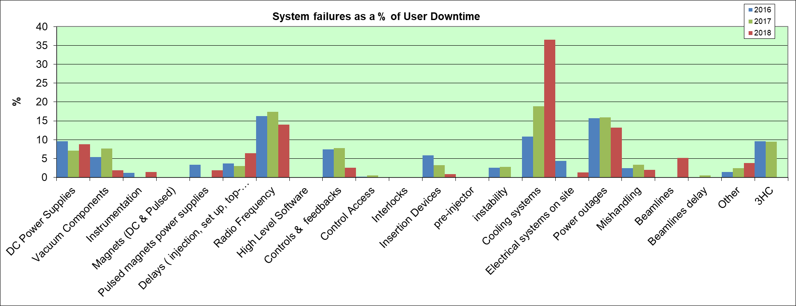
Figure 1: System failures as percentage of user downtime for 2016, 2017 and 2018.
The top-up availability to the total user scheduled time since 2010 is above 97% and its value for 2018 was 98.4%. The remaining percentage indicates functioning in decay mode due to some failure. In top-up operation, we consider as downtime when the intensity goes below a certain threshold (260 mA at 2.0 GeV and 120 mA at 2.4 GeV). Top-up contributes also to a very good short and long-term orbit stability. When the air temperature stays constant within ±1 0C , the long term (2 to 5 days) orbit stability is at ±5 µm maximum while the short term (24 hours) at less than 10% of the beam size (1.7 µm horizontally and 1.2 µm vertically).

Elettra 2.0
After 25 years of serving the user community with excellent results, a major upgrade towards the so-called a diffraction limited storage ring (DLSR) is planned for Elettra in order to remain competitive for synchrotron research and enable new science and new technology developments.
Already since 2014 discussions with users and partners started in order to define the requirements of the machine described in a series of papers [7-11] resulting to a preliminary but otherwise complete CDR [12]. Lately in a workshop held at ICTP, Trieste in December 2017 users and partners discussed also other possibilities except the high brilliance such as the inclusion of super-bends, in-vacuum undulators, more space for insertion devices, and finally yet importantly, the possibility of short pulses as well as operating at 2 energies as presently. The short pulse possibility and the science of light sources in the next 30 years were also the subject of two new workshops organized by Elettra and held at ICTP in December 2018.
Based on the new revised requirements an enhanced version of our S6BA (symmetric six bend achromat) was produced namely S6BA-E by using longitudinal gradient (LG) dipoles (4 per achromat) (Fig. 3) and bending quadrupoles (8 per achromat). This way the emittance of 98 pm-rad at 2 GeV or 140 pm-rad at 2.4 GeV was achieved [13] at 1% coupling. Since the peak field of the LG dipoles at 2.4 GeV was above 2 T we have rescaled the peak field to stay below 2 T at 2.4 GeV.
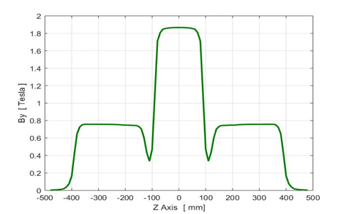
Figure 4: LG dipole magnet profile.
The symmetric six bend enhanced achromat (S6BA-E) lattice consists of six quad-dipole-quad cells per achromat creating an invariant optic under relative position shifts between them. Thus, short straight section in the arcs are created without appreciable change of the optics functions, increasing thus the space available for insertion devices. Although the symmetry originally was 12-fold, on beam lines request changed to 6-fold with free space in the long straight sections for IDs of 4 alternating with 5 meters. Further matching as good as possible the beta functions we have obtained a very versatile and flexible lattice as shown in Fig. 4.

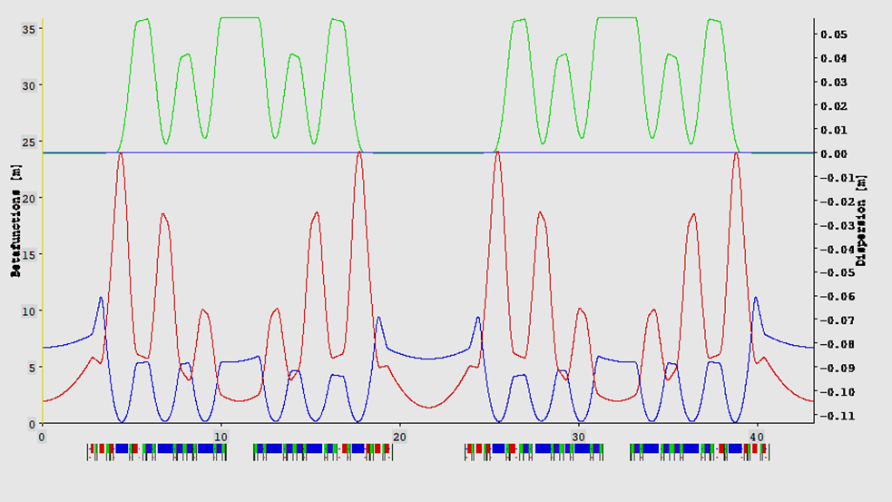
Figure 3: The S6BA_E lattice with LG dipoles (2-4 from left at each achromat) and reverse bend quadrupole / dipoles.
The S6BA-E lattice has a bare emittance of 145 pm-rad at 2 GeV and 207 pm-rad at 2.4 GeV at 1% coupling i.e. a factor of 50 reduction from the present machine emittance. At full coupling, the emittances become respectively 70 and 100 pm-rad. Another interesting point of this lattice is that due to its low momentum compaction of about 9e-5, it can provide a short stable electron bunch below 10 ps (FWHM) at low intensities with acceptable lifetime of about 12 h for a 10 mA total current. For the full intensity case (400 mA), a superconductive third harmonic cavity lengthens the bunch for stability and lifetime, in this case the Touschek lifetime will be 13 h at 2% coupling. The working point is (33.25, 9.2-9.4) and the natural chromaticities (-71,-70). All dipoles are having vertical gradient, in the parts with gradient the dipole field is 0.6 to 0.8 T and the maximum gradient is ≤22 T at 2.4 GeV (compared with 4 T/m in Elettra). The quadrupoles have maximum gradients ≤50 T/m (compared with 18 T/m in Elettra). The high field parts of the LG dipoles (fig. 3) are without gradient and the field there varies from 1.4 T at 2 GeV to 1.7 T at 2.4 GeV.
The light exits from dipole beam lines are at the fourth dipole (the one immediately after the short straight section) at each achromat, which is a LG dipole. Since the LG high dipole field is about the same with the dipole field of the actual machine, the dipole beam lines will not suffer any change. However, certain dipole beam lines prefer in the new machine to obtain light from a short wiggler of 1.3 m long and 1.5 T that will be installed in the 1.55 m short straight section. Two such devices are for the moment required. Since the dispersion in the arcs is low (58 mm compared with 400 mm in the actual Elettra) not a large increase of the emittance from such devices has been already calculated.
The hard X-ray imaging (life and material science) requires 10¹³ ph/s at 50 keV and the absorption/x-ray fluorescence requires the same flux at 35 keV that can be satisfied using three super-bends, two at 6 T and one at 3.5 T. In that case, the emittance increases at about 15%. The field profile of the super-bends will be similar to that of the LG dipoles shown in Fig. 3 with the difference that the central field will be at 6 T for an angle of 3.6 degrees and pole length of 80 mm. The overall magnetic length will be 800 mm thus there will be two parts of 360 mm each with low field and gradient.
Elettra 2.0 will have three new micro-spot beam lines that the present machine cannot support. All three require a flux of 10¹⁴ ph/s at the source and are the μXRD, μXRF and HB-SAXS beam lines with different specifications in terms of spot size and photon energy range. To meet the requested performance the source point should be a low-gap undulator of at most 6 mm aperture therefore should be an in-vacuum device. Simulations show that undulators with K_{max}=2 and 20 mm period at 2.4 GeV will provide the 7th, 9th, 11th and 13th harmonics with the required flux and energy range while the brilliance is above 10²¹ ph/s/mm²/mrad²/0.1% BW
In Fig. 5, the complete geometry of the new machine is shown including some new and old elements. Some of the already used insertion devices will be refurbished and reused.

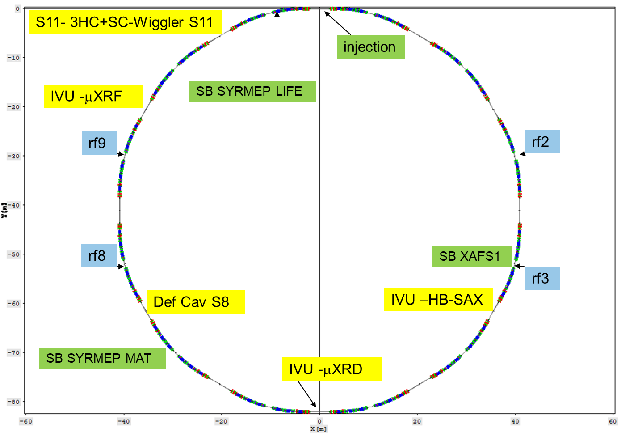
Figure 6: Machine geometry indicating the positions of the super-bends, some IDs and the rf cavities.
As mentioned above Elettra 2.0 will operate initially at both 2.4 and 2 GeV with the gradual phasing out of the 2 GeV operation. In the following Table 1, we present the initial and final (after intra-beam scattering (IBS) at 400 mA) emittances at 2 and 2.4 GeV for various couplings.
Table 1: Beam Emittance for Both 2 and 2.4 GeV Including the Intra-Beam Scattering Effect.
E=2 GeV | 2 % | 10 % | 100 %
𝜀 initial (bare pm-rad) | 142 | 132 | 70
𝜀 final (incl. IBS pm-rad) | 235 | 185 | 103
E= 2.4 GeV
𝜀 initial (bare pm-rad) | 204 | 189 | 104
𝜀 final (incl. IBS pm-rad) | 230 | 206 | 130

The corresponding horizontal beam sizes including IBS in the long straight sections is 42 μm in the horizontal and 2 μm in the vertical at 2% coupling while the divergence is 4 x 2 μrad. In the short straights (1.55 m), the beam dimensions are about 66 x 4 μm and 4 x 5 μrad.
In conclusion, we have designed the next generation DLSR Elettra 2.0 seriously considering the users requests, optimizing the relation emittance vs. final photon beam at the experiment and maximizing the slots available for insertion devices. The emittance at 1% coupling is 50 times less that of the present machine certainly an important achievement without reducing the available space for insertion devices.

References
[1] E. Karantzoulis et al., “Top-up implementation and operation at Elettra”, in Proc. 1st Int. Particle Accelerator Conf. (IPAC’10), Kyoto, Japan, May 2010, paper WEPEA028, pp. 2543-2545.
[3] E. Karantzoulis et al., “Top-up operational experience at Elettra”, in Proc. 1st Int. Particle Accelerator Conf. (IPAC’10), Kyoto, Japan, May 2010, paper WEPEA028, pp. 2543-2545.
[3] E. Karantzoulis et al., “Elettra status and upgrades”, in Proc. 5th Int. Particle Accelerator Conf. (IPAC’14), Dresden, Germany, June 2014, paper MOPRO076, pp. 261-263.
[4] E. Karantzoulis et al., “Elettra status and future prospects”, in Proc. 6th Int. Particle Accelerator Conf. (IPAC’15).
[5] E. Karantzoulis et al., “Elettra status and upgrades”, in Proc. 7th Int. Particle Accelerator Conf. (IPAC’16), Busan, Korea, May 2016, paper WEPOW018, pp. 2864-2866.
[6] S. Di Mitri and E. Karantzoulis, “Betatron coupling numerical study at Elettra”, in Proc. 5th Int. Particle Accelerator Conf. (IPAC’14), Dresden, Germany, June 2014, paper MOPRO077, pp. 264-266.
[7] E. Karantzoulis, “Evolution of Elettra towards an ultimate light source”, in Proc. 5th Int. Particle Accelerator Conf. (IPAC’14), Dresden, Germany, June 2014, paper MOPRO075, pp. 258-260.
[8] E. Karantzoulis, “Electra 2.0-The next machine”, in Proc. 6th Int. Particle Accelerator Conf. (IPAC’15), Richmond, VA, USA, May 2015, paper TUPWA052, pp. 1532-1534.
[9] E. Karantzoulis, “The diffraction limited light source Electra 2.0”, in Proc. 8th Int. Particle Accelerator Conf. (IPAC’17), Copenhagen, Denmark, May 2017, paper WEPAB036, pp 2660-2662.
[10] E. Karantzoulis et al., “Status of Elettra and future upgrades”, in Proc. 9th Int. Particle Accelerator Conf. (IPAC’18), Vancouver, BC, Canada, May 2018, paper THPMF010, pp 4054-4056.
[11] E. Karantzoulis, "Elettra 2.0 - The diffraction limited successor of Elettra", Nuclear Inst. and Methods in Physics Research, A 880 (2018) 158–165.
[12] E. Karantzoulis et al., “Elettra 2.0 Technical Conceptual Design Report”, ST/M-17/01, Elettra– Sincrotrone Trieste, internal document (2017).
[13] E. Karantzoulis and W. Barletta "Aspects of Elettra 2.0 design", Nuclear Inst. and Methods in Physics Research, A 927 (2019) 70–80.

