Table of Content
Software and System Tools and Applications 1
Standard Base Software 2
Configuration Requirements and Notes 3
Quick Guide 4
System 4
Adobe Acrobat Pro 5
1. Access Preferences Menu 5
2. General Settings 6
3. Page Display 7
4.1 Content Editing 8
4.2 Content Editing 9
5.0 Convert From PDF 10
7.0 Javascript 13
8.0 Search 14
9.0 Units and Guides 15
Copy Doting Script to the Correct Location 16
Distiller Configuration 17
Word 24

Software and System Tools and Applications

Standard Base Software
Item | Software/Configuration/Plugin | Word Editing | Latex Editing | Open Document Editing | Presentation Editing
 | PDF EDITING
1 | Adobe Acrobat Pro 9 or above (DC)
2 | Barcode Font
3 | Crop and Dotting Script for Acrobat JACoWSetDot.js
4 | Distiller Options  JACoW-10.joboptions
5 | Enfocus PitStop
6 | Pitstop Media Box JACoW Media Box.eal
 | SYSTEM TOOLS ETC
7 | Font Liberation Mono  Liberation Mono - .ttf
8 | Anti-Virus
9 | Compression Tools (7-Zip, WinZip, WinRAR)
 | SYSTEM MEDIA
10 | VLC Media Player
11 | K-Lite Codec Pack
12 | IrfanView
13 | CamStudio
14 | VirtualDub
15 | Handbrake
 | WEB BROWSERS
16 | Web Browser Firefox (User Preferred)
17 | Web Browser Chrome (User Preferred)
18 | Microsoft Edge (User Preferred)
 | DOCUMENT EDITORS
19 | Microsoft Word
20 | LibreOffice Writer
21 | Miktex
22 | TeXStudio, Texmaker, TeXnicCenter
23 | Notepad++
 | SLIDES TOOLS
24 | Microsoft PowerPoint
25 | Transparency Splitting ( PPspliT ) The zip file password is:“ppsplit”
26 | Keynote (on mac systems)
27 | Mac Fonts

Finding Software Online
Item | Download Locations
1 | https://github.com/JACoW-org/AcrobatPitStopTools | Repository of addins
2 | https://github.com/JACoW-org/AcrobatPitStopTools/tree/master/barcode_font | (Right click on Raw, Save Link As)
3 | https://github.com/JACoW-org/AcrobatPitStopTools/blob/master/JACoWSetDot.js | (Right click on Raw, Save Link As)
4 | https://github.com/JACoW-org/AcrobatPitStopTools/blob/master/JACoW-10.joboptions
6 | https://github.com/JACoW-org/AcrobatPitStopTools/blob/master/JACoW%20Media%20Box.eal
7 | https://www.freebestfonts.com/liberation-mono-font | Download front site and install on system
9 | https://www.7-zip.org/ | Download and Install
10 | https://www.videolan.org/vlc/ | Download and Install
11 | https://codecguide.com/download_k-lite_codec_pack_full.htm | Download and Install
12 | https://www.irfanview.com/64bit.htm | Download and Install, also install full plugins
13 | https://camstudio.org/ | Download and Install
14 | https://virtualdub.org/ | Download and Install
15 | https://handbrake.fr/ | Download and Install
21 | https://miktex.org/, https://miktex.org/howto/install-miktex | Download and Install
23 | https://notepad-plus-plus.org/downloads/ | Download and Install
25 | http://www.maxonthenet.altervista.org/ppsplit.php  https://www.jacow.org/JTM2016/ProcessingTransparenciesEmbeddingAnimations | See instructions on JACoW.org

Configuration Requirements and Notes
System | Notes for Font Install
Adobe Acrobat | Configure Acrobat, install script
Adobe Distiller | Configure install JACoW-10.options, See below or Quick Guide
Word
Pitstop | See Quick Guid
PowerPoint | https://www.jacow.org/uploads/Editors/Slides_Processing_Manual_V4

Quick Guide
Quick info for Acrobat/PitStop/PowerPoint scripts and tools

* JACoW-09.joboptions - JACoW 2009 JobOptions for Acrobat Distiller
* JACoW-10.joboptions - JACoW 2010 JobOptions for Acrobat Distiller
* JACoW Media Box.eal - JACoW Crop Media Box Action List for Enfocus PitStop
* JACoWSetDot.js - JACoW Acrobat extension to assign dots+ on paper
* SplitAnimations.ppa - PowerPoint add-in to split animation when creating PDF
* SplitAnimations.ppt - "Workspace" for developing the SplitAnimations.ppa PowerPoint add-in
* barcode_font - TrueType font needed by JACoWSetDot.js to create the barcode onto papers

Instructions on how to use these files.

JobOptions:
copy the file into the Acrobat | Settings folder (or import via Distiller
via the "Settings | Add Adobe PDF Settings..." menu entry.

Media Box Action List:
Import from PitStop "Run Action List" menu item by right-clicking on the "Local"
folder and then choosing "Import/Export..."

JACoWSetDot.js
First, install the "fre3of9x.ttf" font into the computer. The exact procedure
may vary from platform to platform. On OSX a warning could be given - just ignore
it and proceed with the installation.
Copy "JACoWSetDot.js" into the Acrobat JavaScript extensions folder.
Also this path could change for different operating system and Acrobat versions.
For Windows 7 and Acrobat 9 it defaults to
C:\Program Files\Adobe\Acrobat 9.0\Acrobat\Javascripts
and for Mac OS X 10.9 and Acrobat 11 it defaults to
~/Library/Application Support/Adobe/Acrobat/11.0/JavaScripts
(the directory may not exist - create it manually).
Also, remember to set the security option in Acrobat's preferences, otherwise
the script won't work. Go under Edit->Preferences->General->JavaScript
and check the "Enable menu items JavaScript execution privileges" option.
Moreover, in the "Identity" tab be sure to have your (editor) name set,
REFERENCES:
- https://helpx.adobe.com/acrobat/kb/user-javascript-changes-10-1.html
- http://www.pdfscripting.com/public/111.cfm

SplitAnimations.ppa
Put it into the \Microsoft\Addins folder.

System
Install Fonts Barcode, and Liberation Mono. Right Click on each font and select install.

Adobe Acrobat Pro
Note: the screen shots may very from version to version of Acrobat

1. Access Preferences Menu
Ctrl + K Access the Preference Menu
Acrobat DC (Standard not Pro) | Acrobat 2017

2. General Settings
Stop Acrobat from generating URLs links in distilled papers. (Uncheck “Create links from URLs”)
Acrobat DC (Standard not Pro)
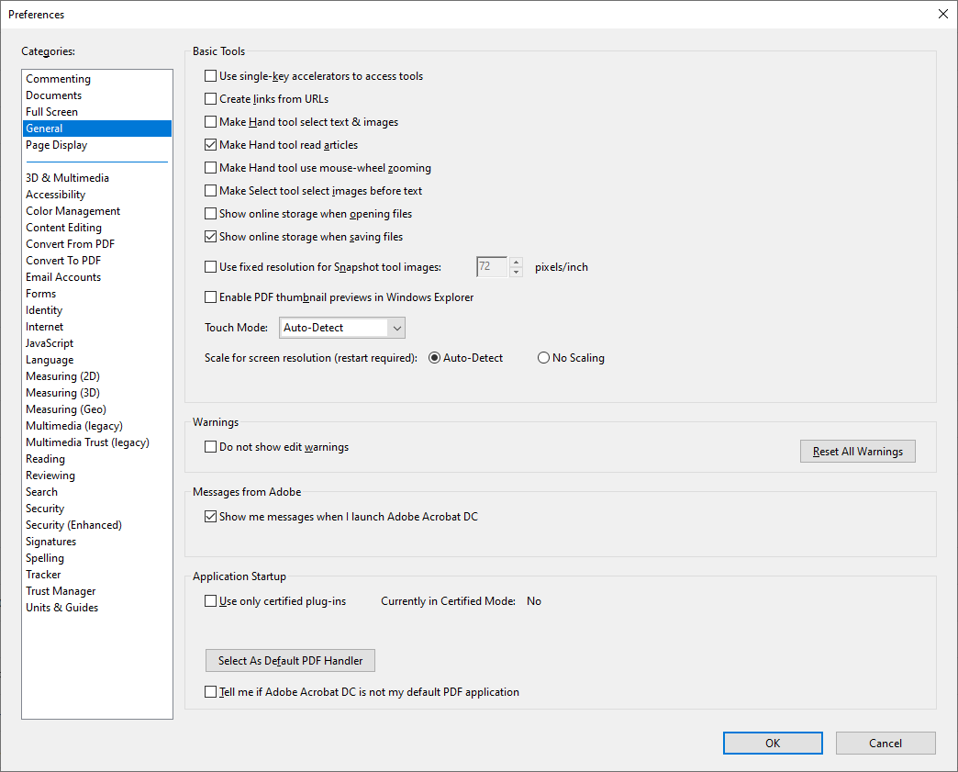
Acrobat 2017
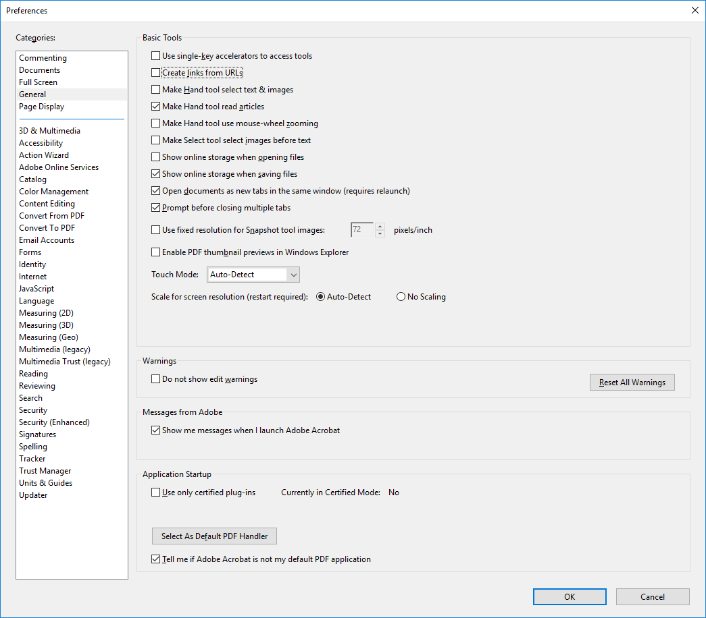

3. Page Display
Display fonts using the fonts in the PDF not local fonts. (Uncheck “Use local fonts”)
Acrobat DC (Standard not Pro)
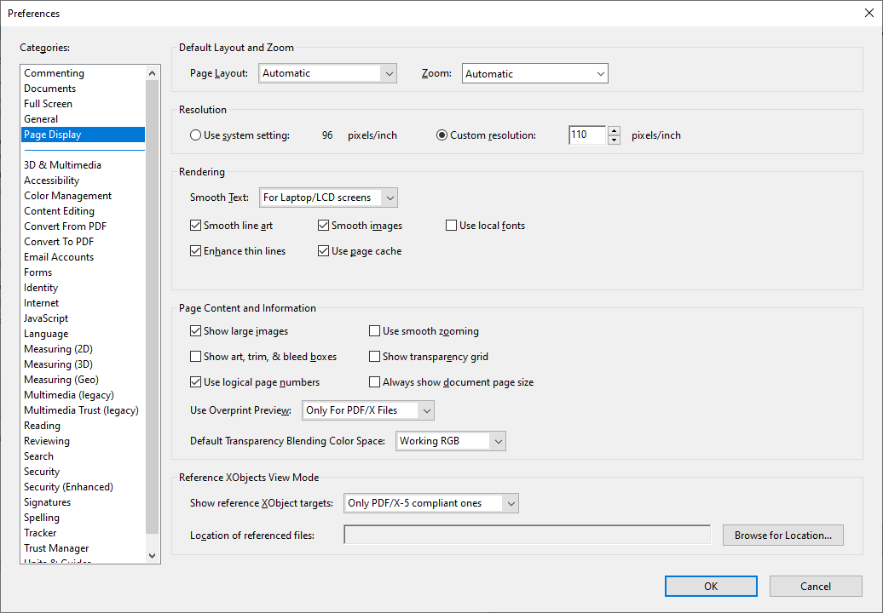
Acrobat 2017
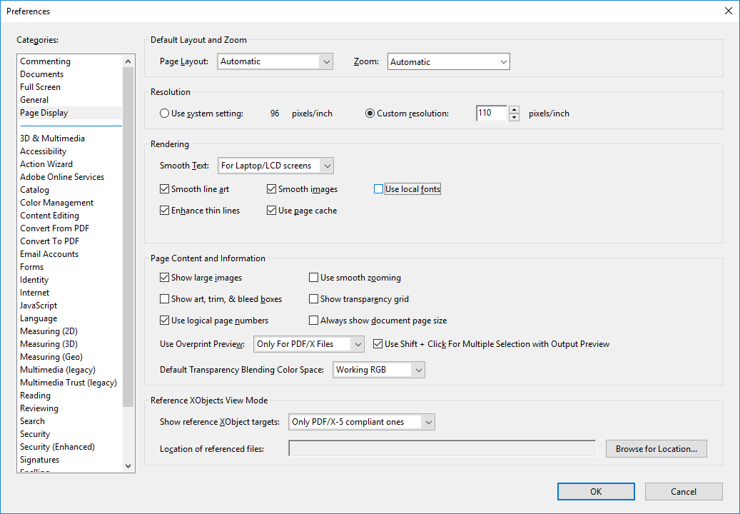

4.1 Content Editing
Make sure Adobe Acrobat displays this as they are. (Uncheck “Enable Artificial Bold/Italic Styles”)
Acrobat DC (Standard not Pro)
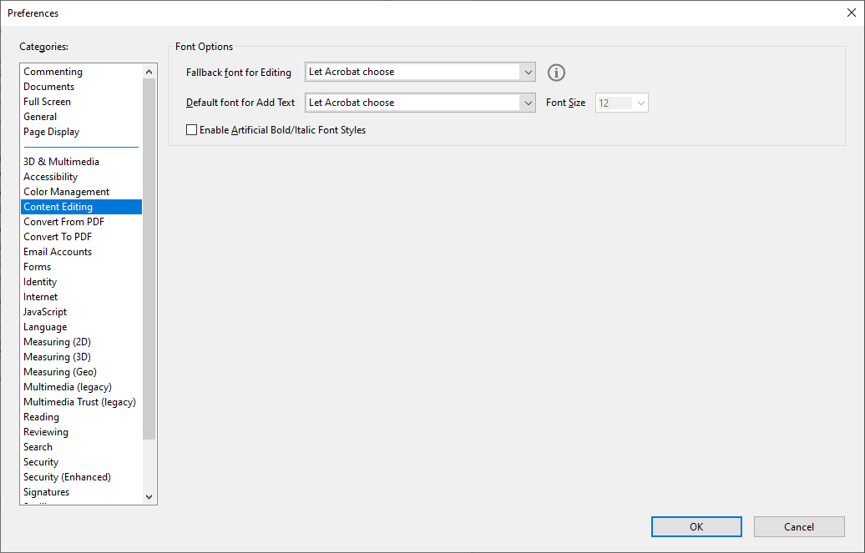
Acrobat 2017
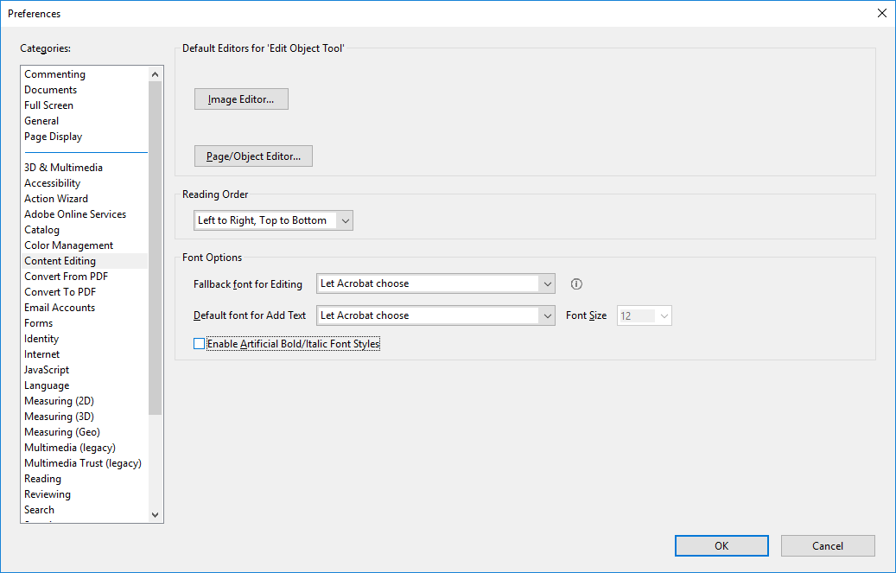

4.2 Content Editing
While editing if you accidentally type changing text in the PDF you may not notice, by setting the editing text and add text to Wingdings 36 font size it will be obvious immediately
Acrobat DC (Standard not Pro)
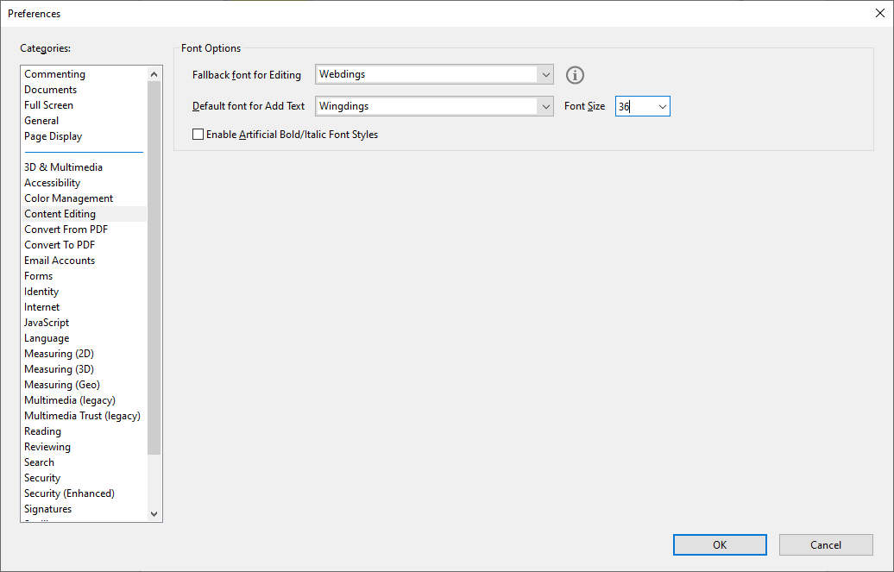
Acrobat 2017
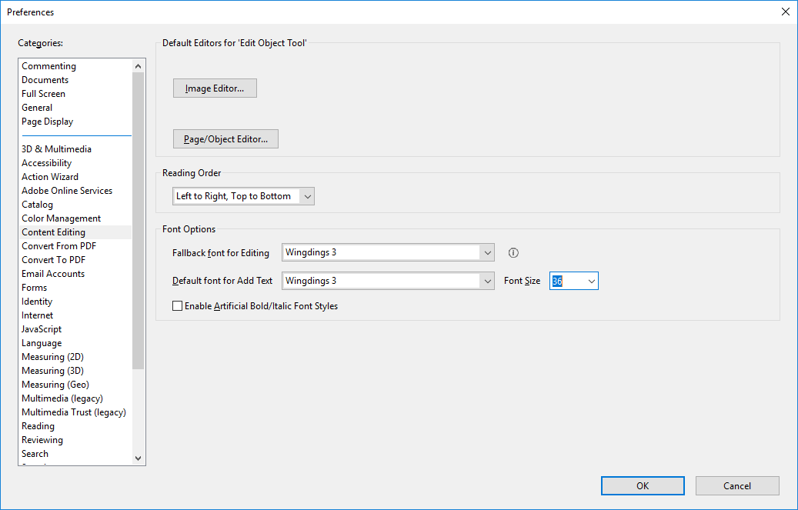

5.0 Convert From PDF
Include all fonts during embedding. In the Encapsulated PostScript drop down menu “Font inclusion” = Embedded and Referenced Fonts, Uncheck Convert TrueType to Type 1.
Acrobat DC (Standard not Pro)
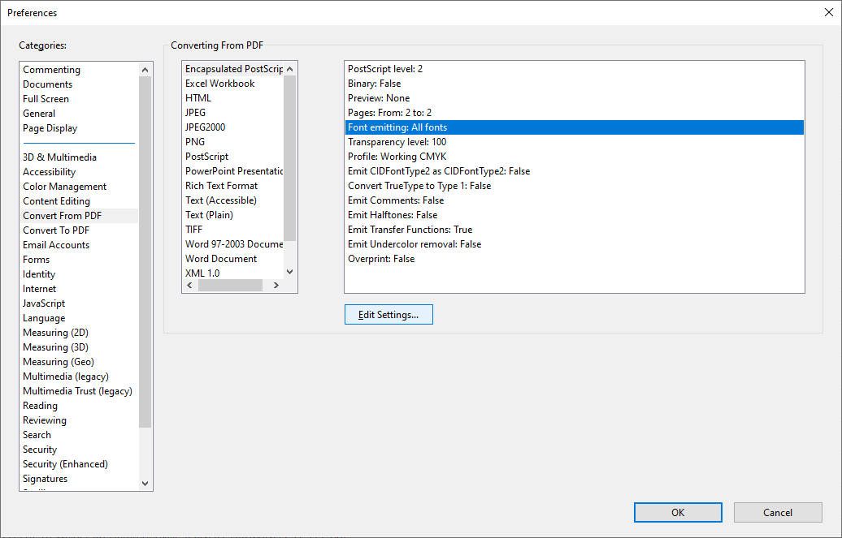
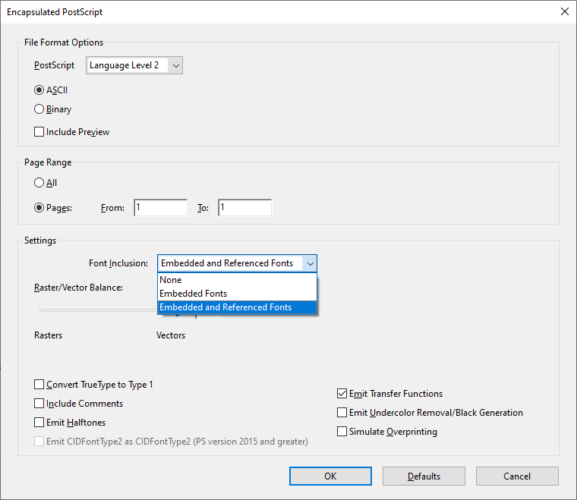

Acrobat 2017
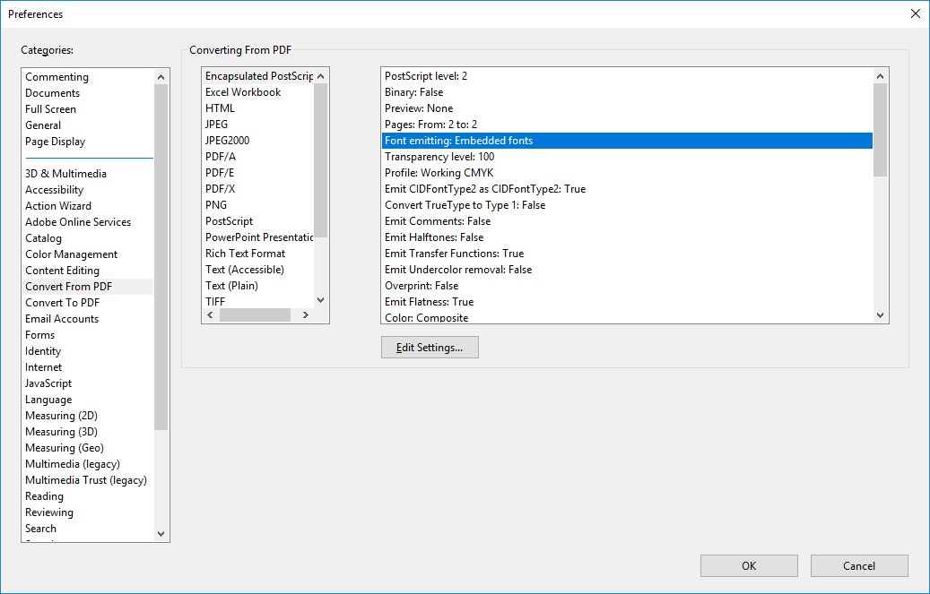
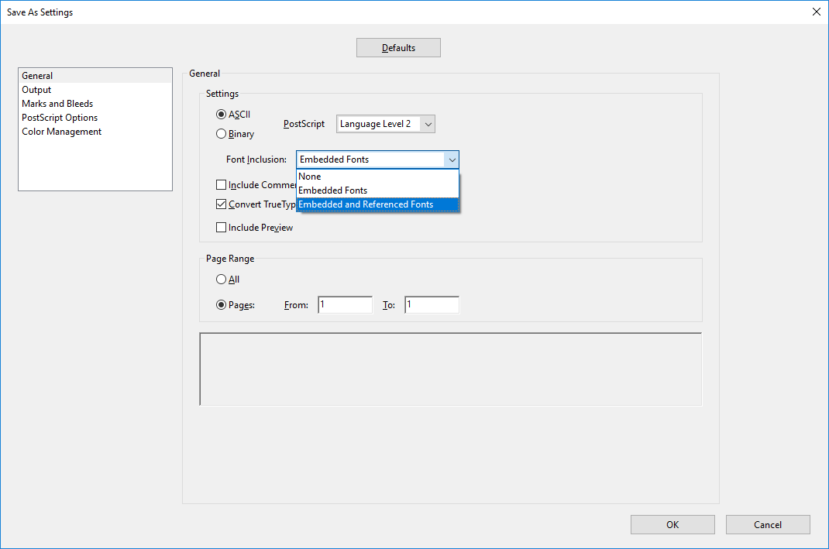

6.0 Identity
Place your name in the identity “Name” field which will be printed on the top of the page when you print a dotted paper.
Acrobat DC (Standard not Pro)
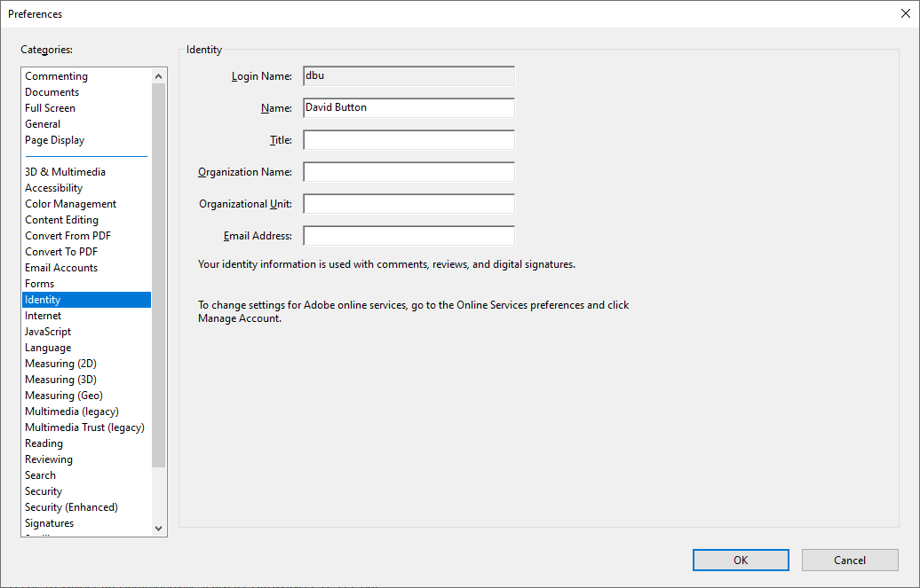
Acrobat 2017
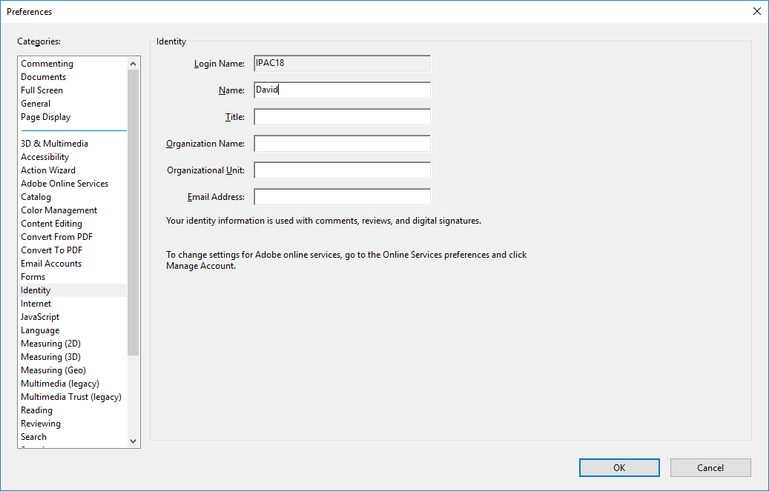

7.0 Javascript
JavaScript > Enable Menu Items > Check Enable menu items JavaScript execution privileges.
Acrobat DC (Standard not Pro)
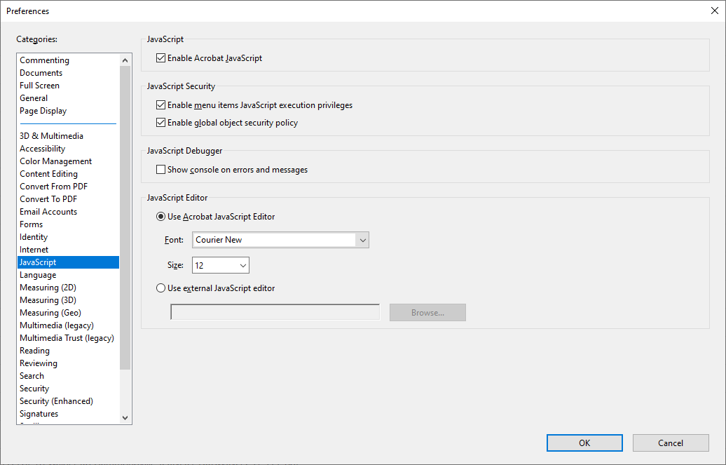
Acrobat 2017
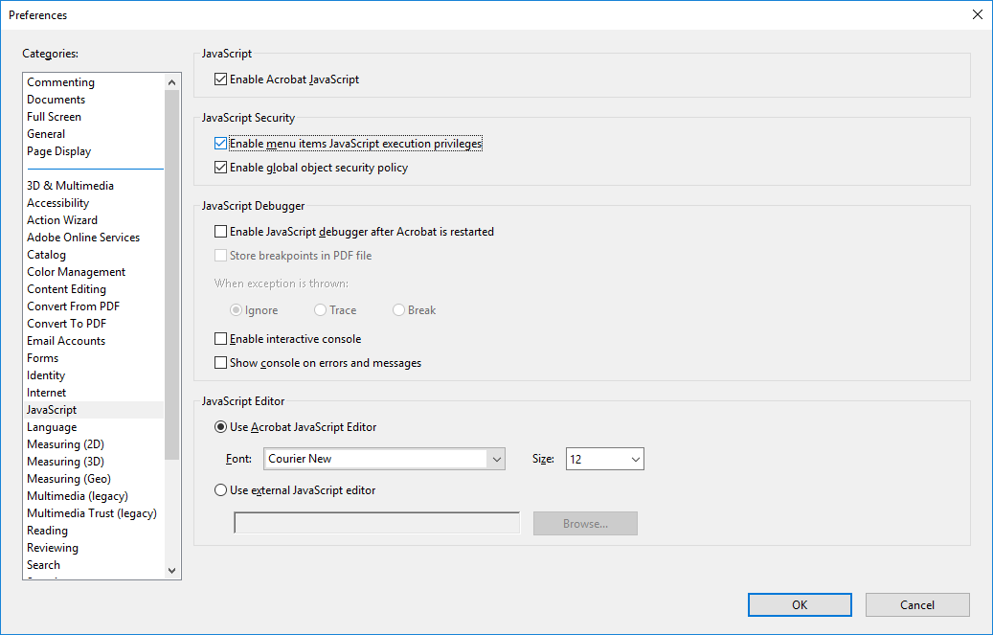

8.0 Search
Configure the Acrobat search tool.
Acrobat DC (Standard not Pro)
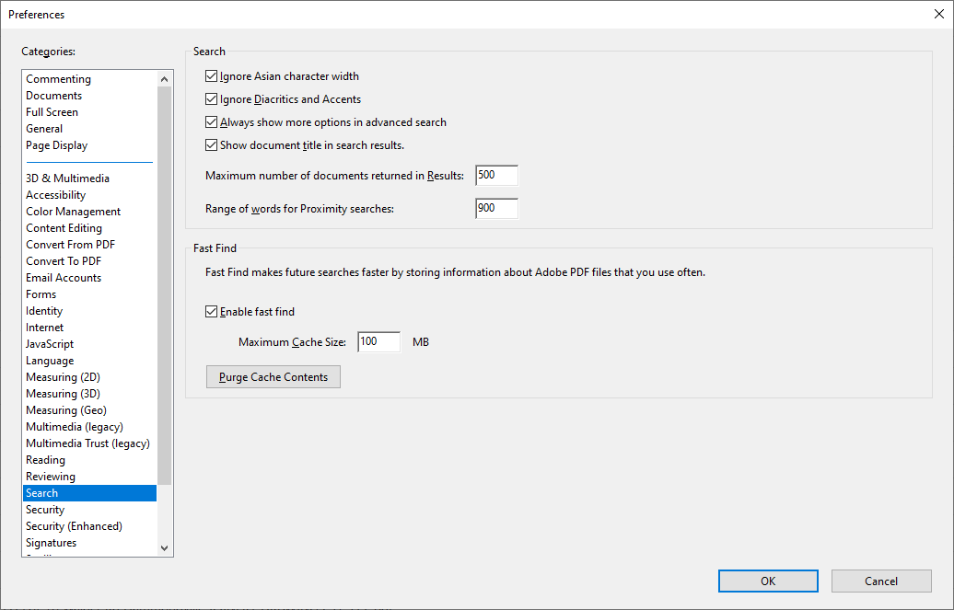
Acrobat 2017
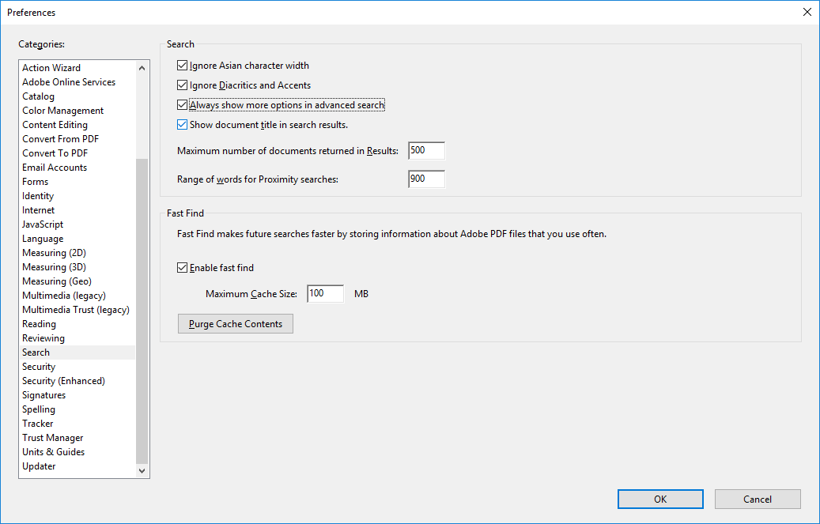

9.0 Units and Guides
Setup the gridline which will show you the margin rules on the page. These are turned on and off using Ctrl + U
Acrobat DC (Standard not Pro)
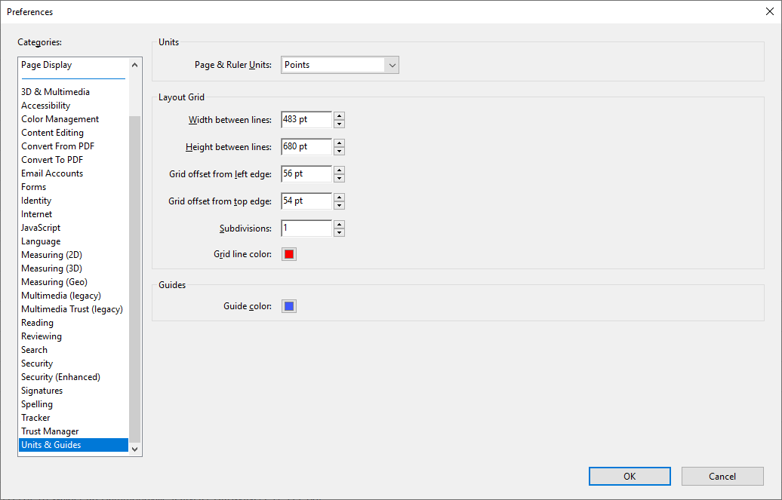
Acrobat 2017
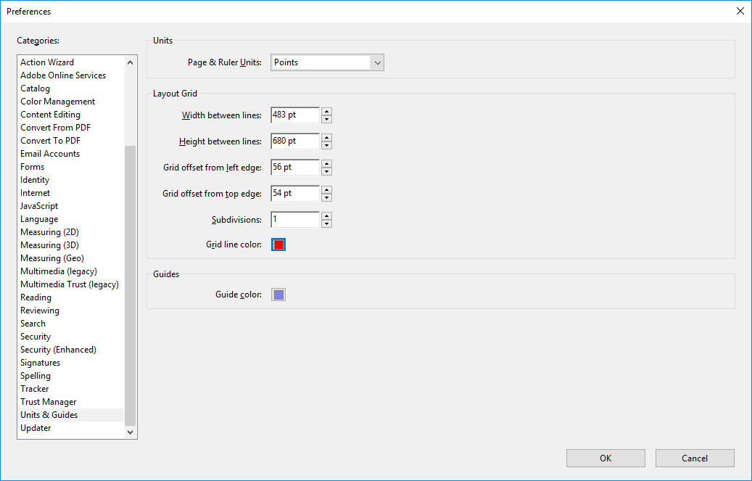

Copy Doting Script to the Correct Location
Place Dotting Script into ……. Directory, note the directory will be named the same as the version of acrobat you are using.
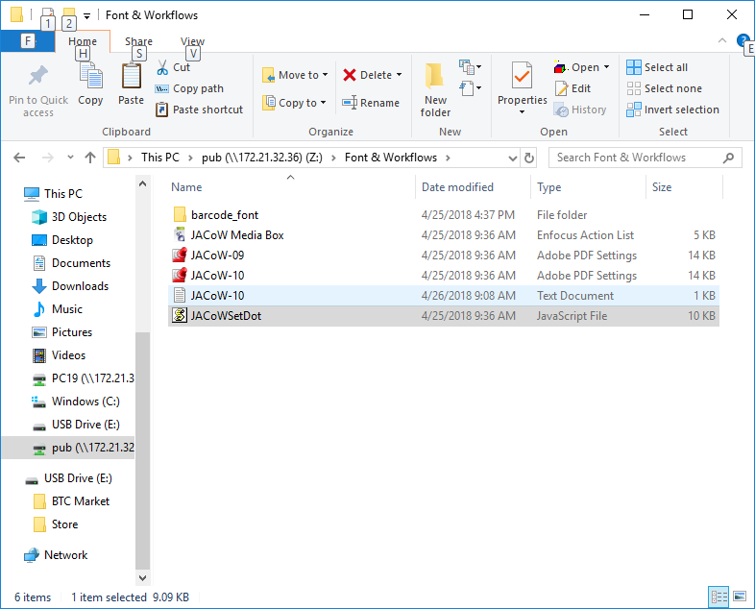
Copy to local temp directory first
C:\Program Files (x86)\Adobe\Acrobat 2017\Acrobat\Javascripts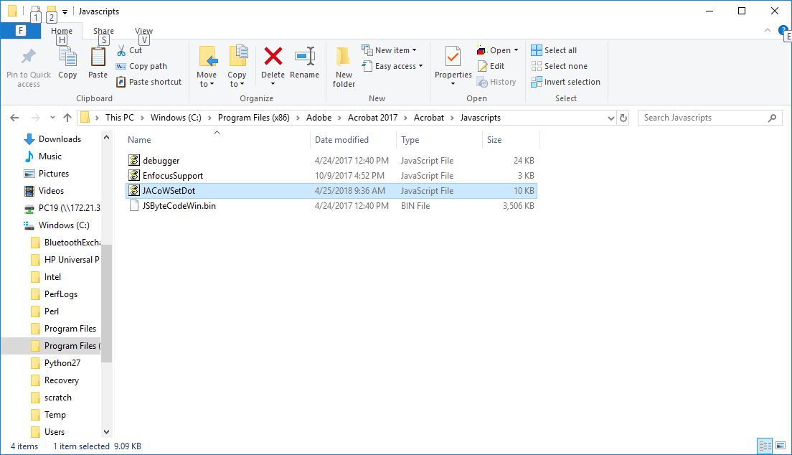

Distiller Configuration
This will explain who to add the JACoW-10 options to the distiller etc.

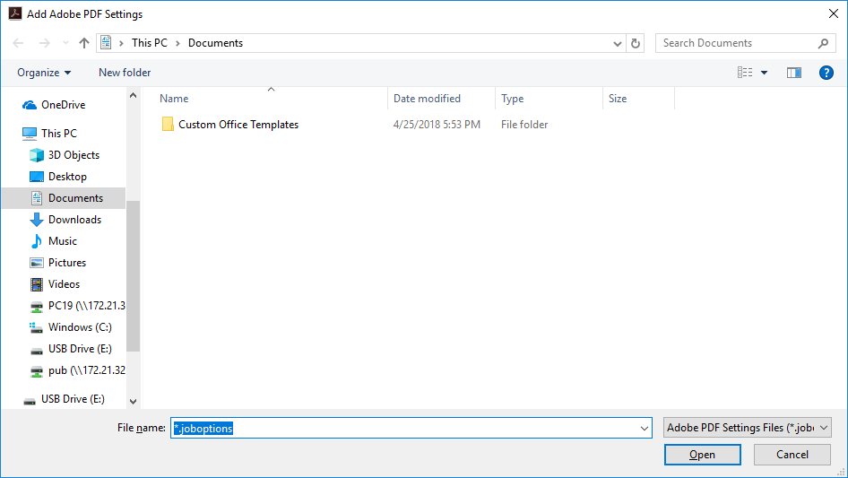
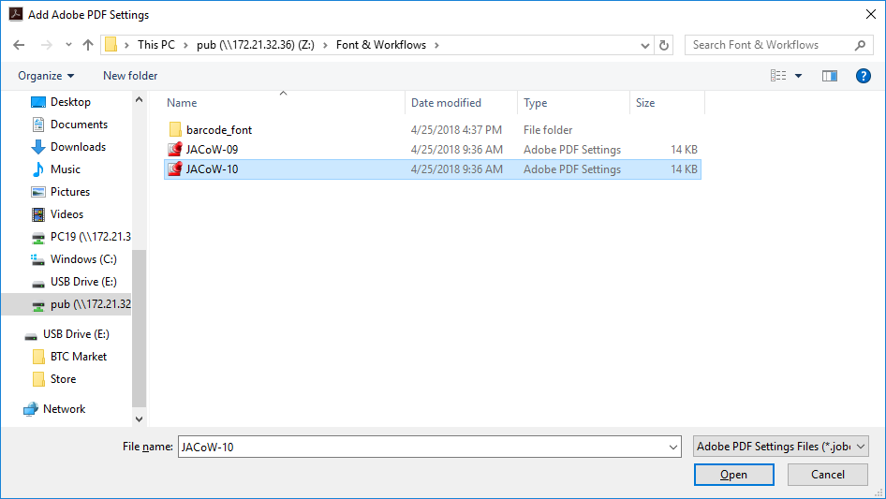
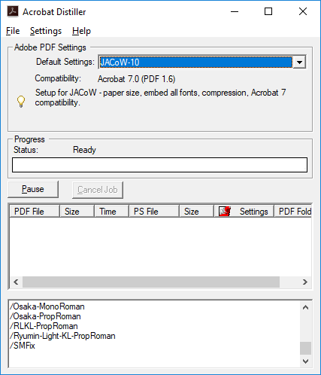
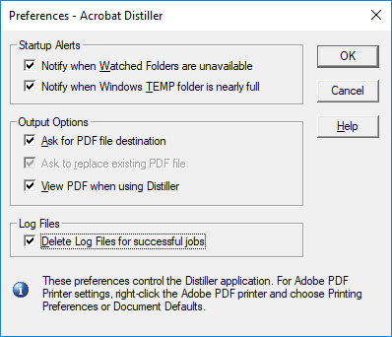

Goto your System printer s Adobe Printer
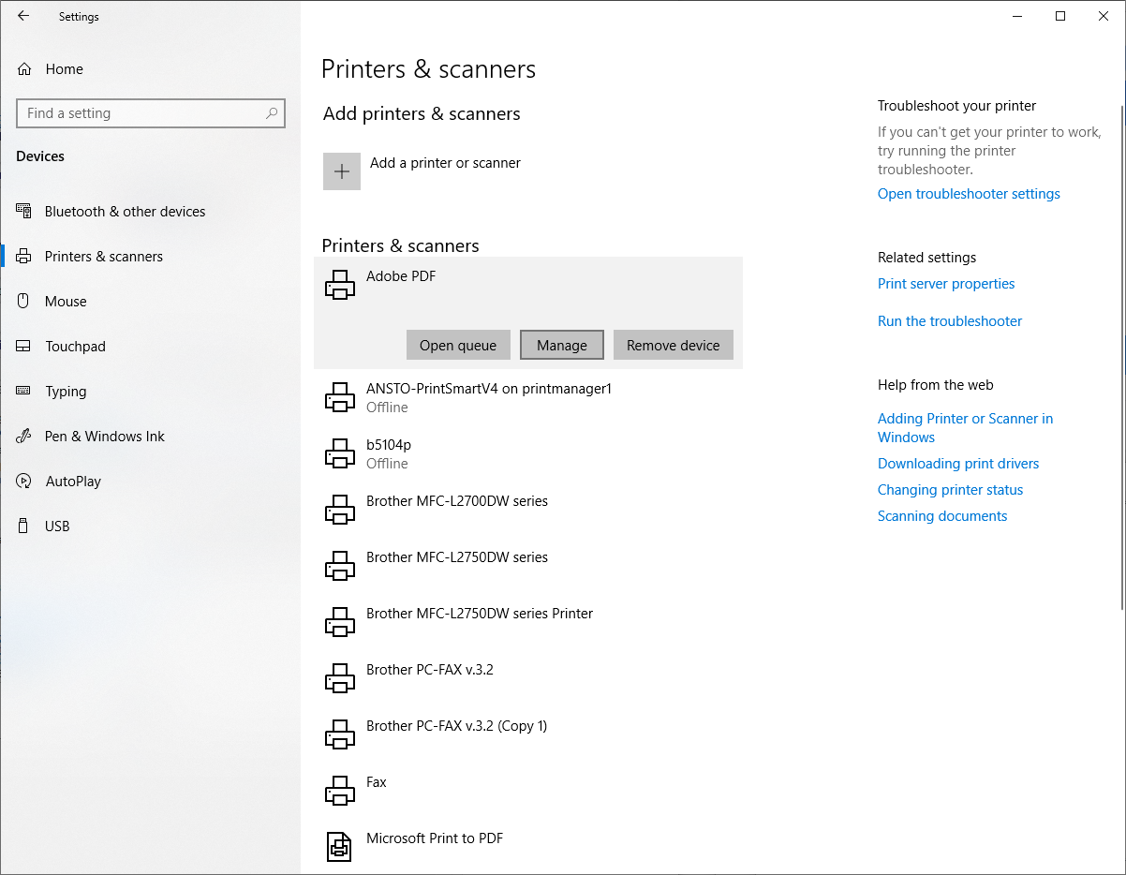
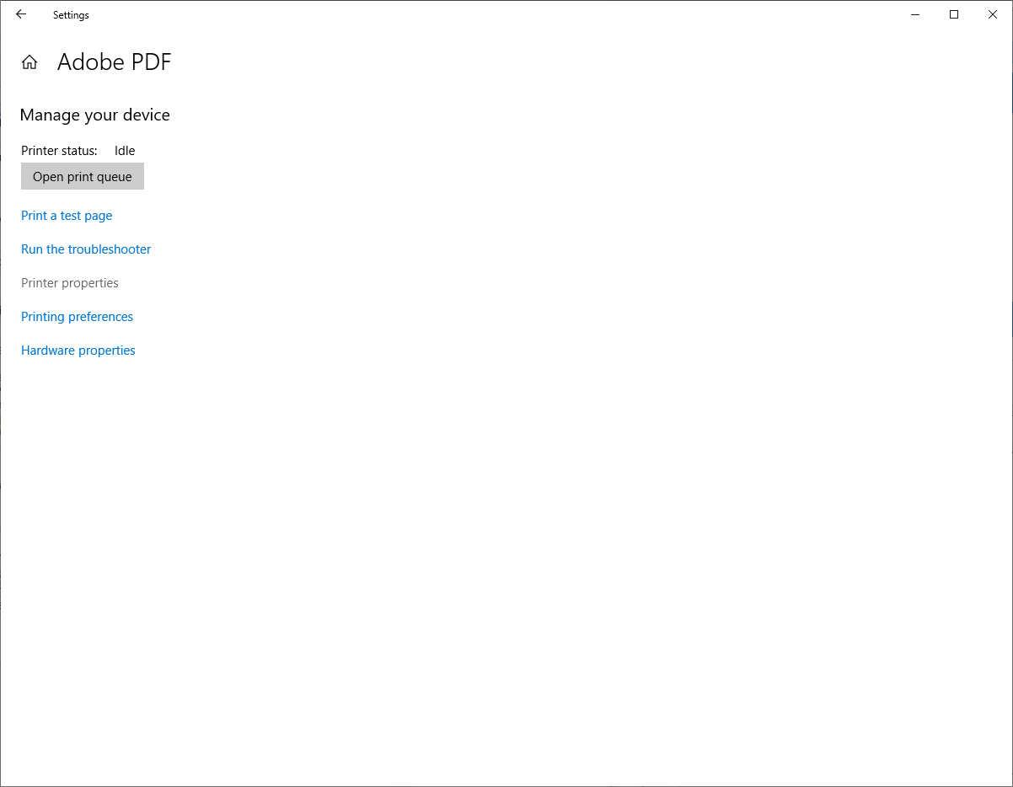
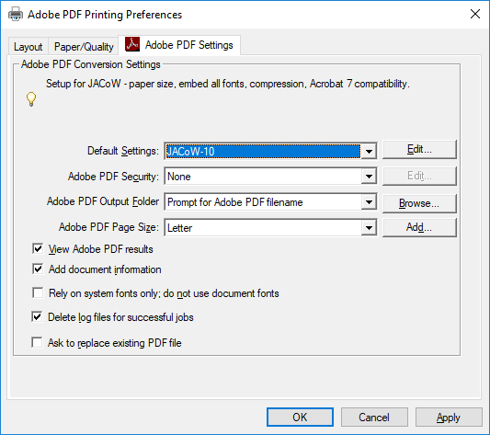

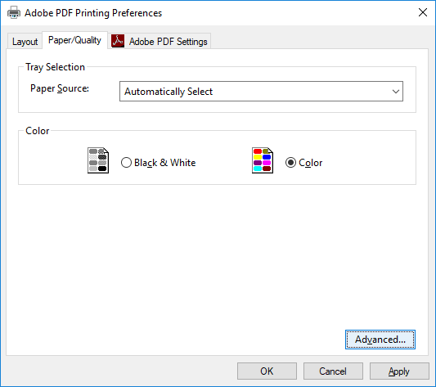
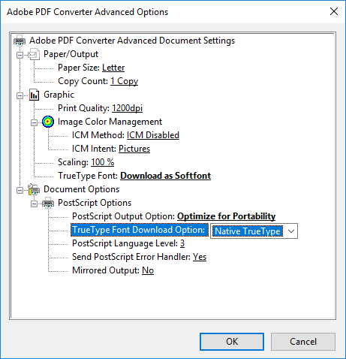

Word
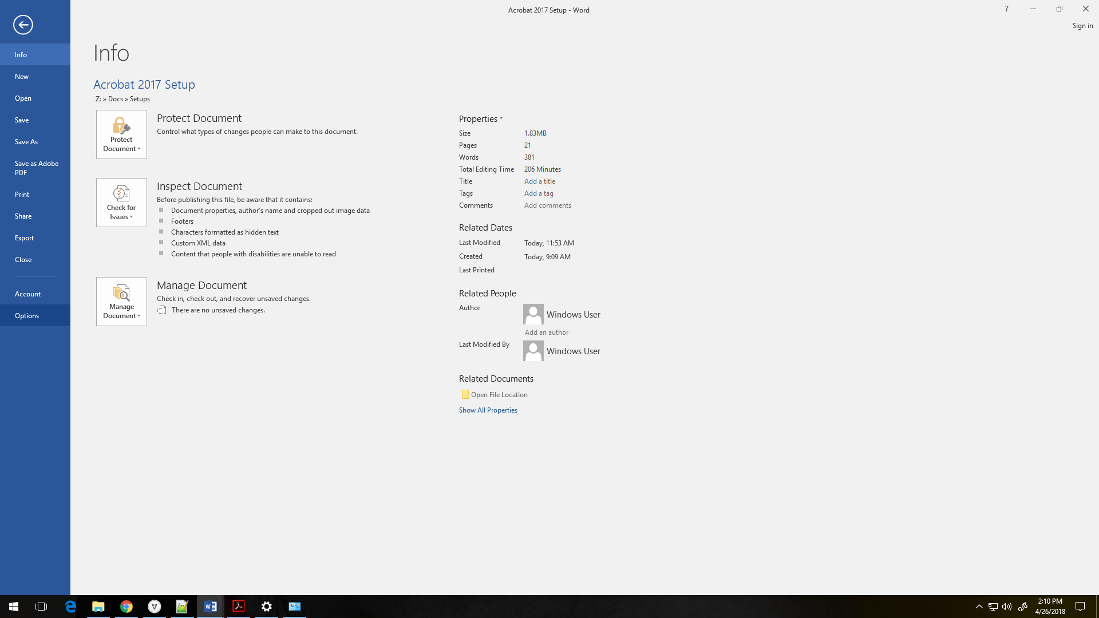
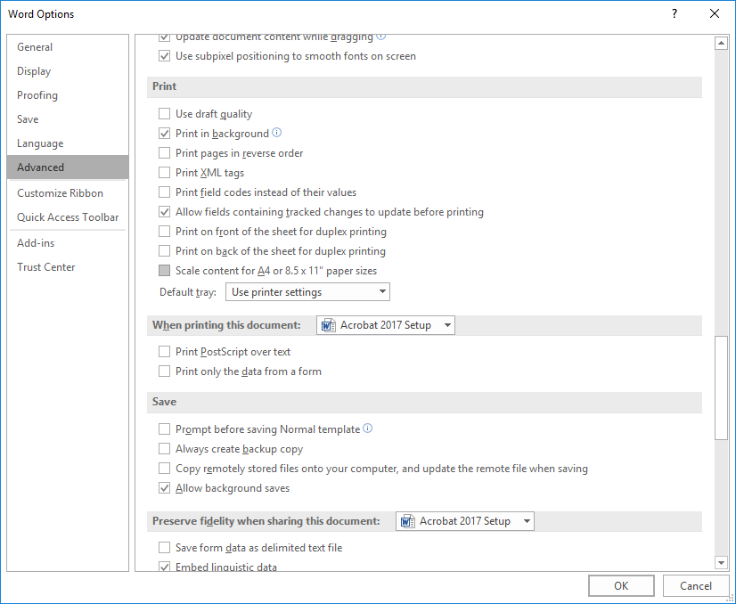

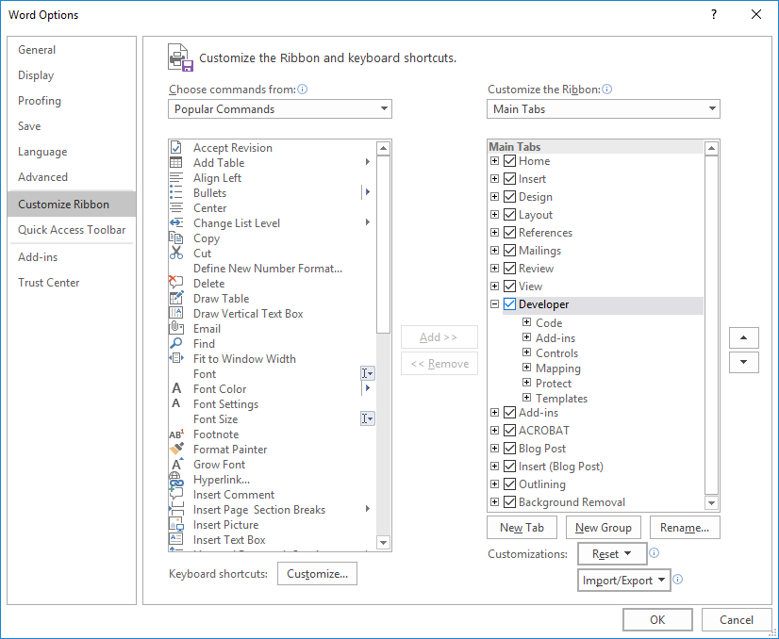
Now will have Development Tab on the Ribbon.
